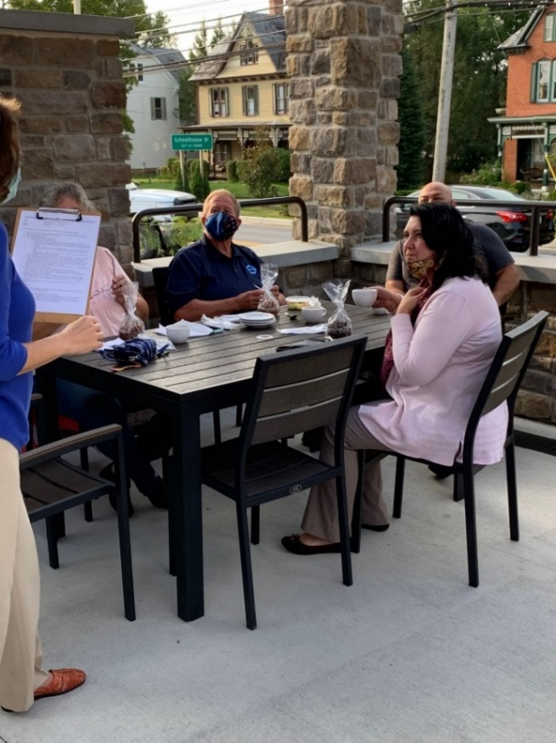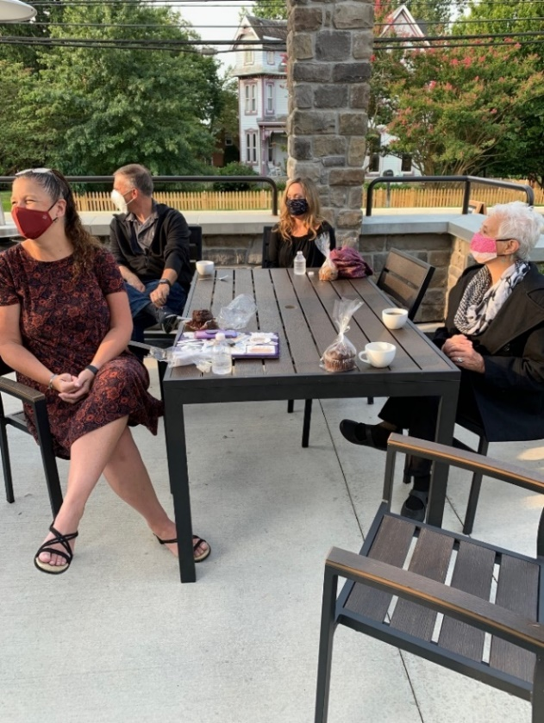

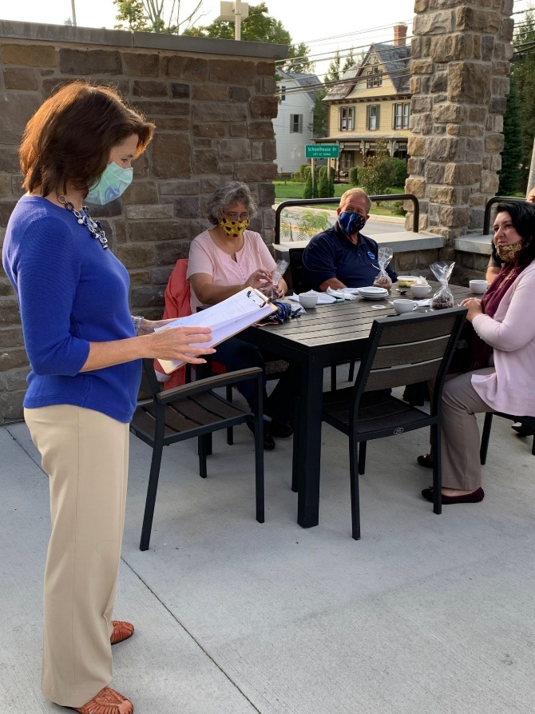 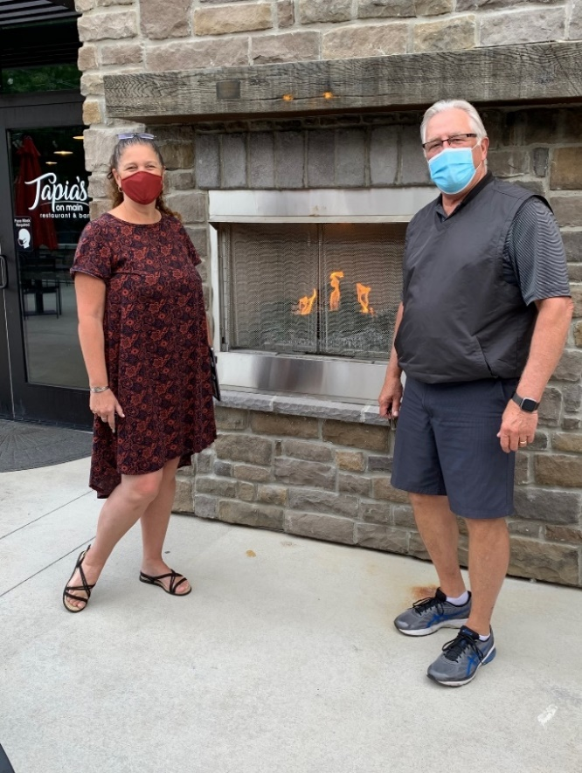Attendees: Patricia Staples (Bryant Financial), Brian and Sheila Considine, Dee Buchanan, Allison Roemer, Martha Pirrone, Jose (Tapia’s), Craig Hauser, Jim Hoover, Janice Rockwell, Heather Light (Pioma)

