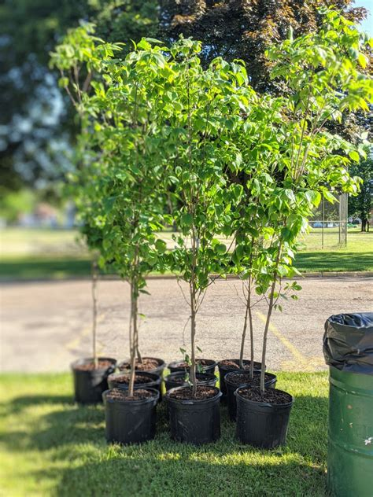
Dear Spring Tree Giveaway Participant,
The Middletown Sustainability Committee thanks you for your participation in the Spring Tree Giveaway event sponsored by Potomac Edison.
Planting trees in your yard helps the town’s sustainability efforts in a couple ways. Trees absorb rainwater and help prevent harmful toxins and pollutants in our watersheds from reaching the Chesapeake Bay. Your actions also help us in reaching one of the town’s sustainable goals of a 25% tree canopy coverage by 2025. Every tree helps!
The Sustainability Committee wants to track the growth of these trees to attract more town residents to take the steps you have and participate in future events and giveaways.
We wish to provide a platform to show appreciation to Potomac Edison for their lead in this project. Our idea is to create a new Webpage on https://www.greenmiddletown.com that contains a pictorial collage of these new trees and their growth over time.
We are asking your participation by sending us a digital picture of your newly planted tree(s) if you have not done so already. Please snap a picture or two with your smart phone and send it to us via e-mail to greenteam@ci.middletown.md.us. For those of you who have already sent us photos (which is a lot of you!!), thank you so much! You’ve done a wonderful job of getting these young trees established for the benefit of generations to come!

