

Website Analytics Report
For WWW.GREENMIDDLETOWN.COM

Report Date: 12 May 2022
Time Frame: Last 365 Days

Traffic over Time
Which months get the most site visits.
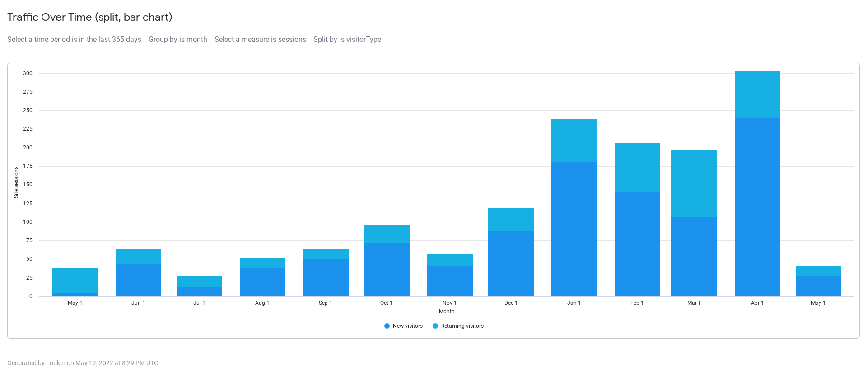
New or returning visitor | New visitors | Returning visitors
Month | Site sessions | Site sessions
05/01/22 | 27 | 14
04/01/22 | 241 | 63
03/01/22 | 108 | 89
02/01/22 | 141 | 66
01/01/22 | 181 | 58
12/01/21 | 88 | 31
11/01/21 | 41 | 16
10/01/21 | 72 | 25
09/01/21 | 51 | 13
08/01/21 | 38 | 14
07/01/21 | 13 | 15
06/01/21 | 44 | 20
05/01/21 | 5 | 34
 | 1,050 | 458
 | Total Sessions | 1,508

New vs. Returning Visitors
How much traffic comes from new vs. returning visitors.

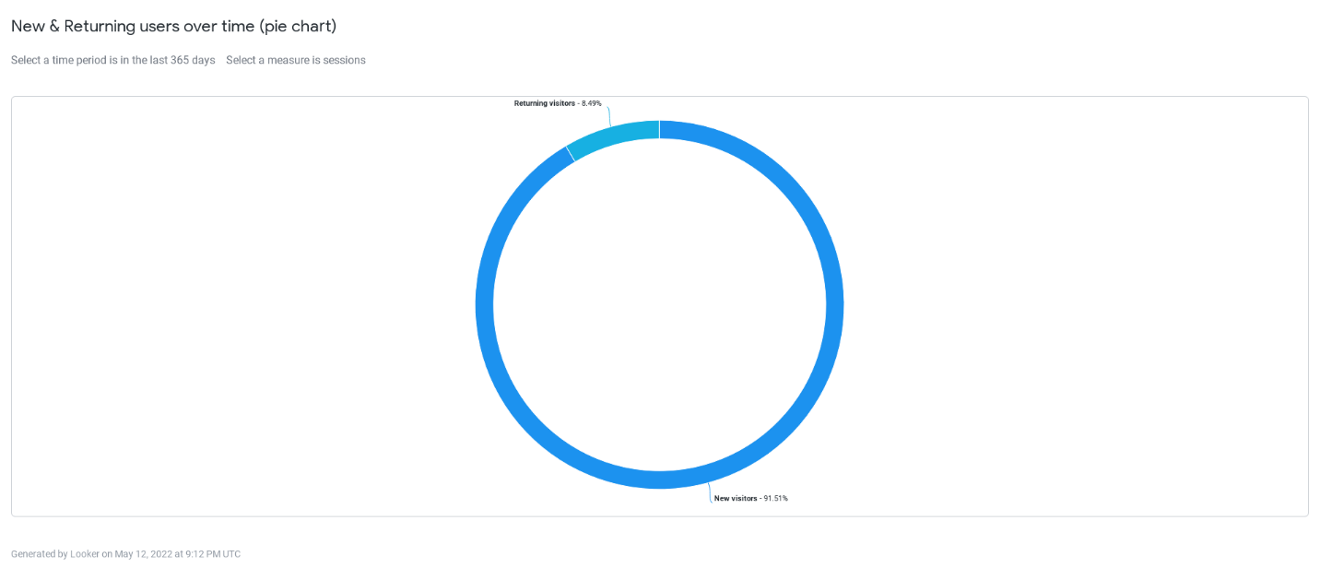

New or returning visitor | Site sessions
New visitors | 1,380
Returning visitors | 128

Traffic by Device
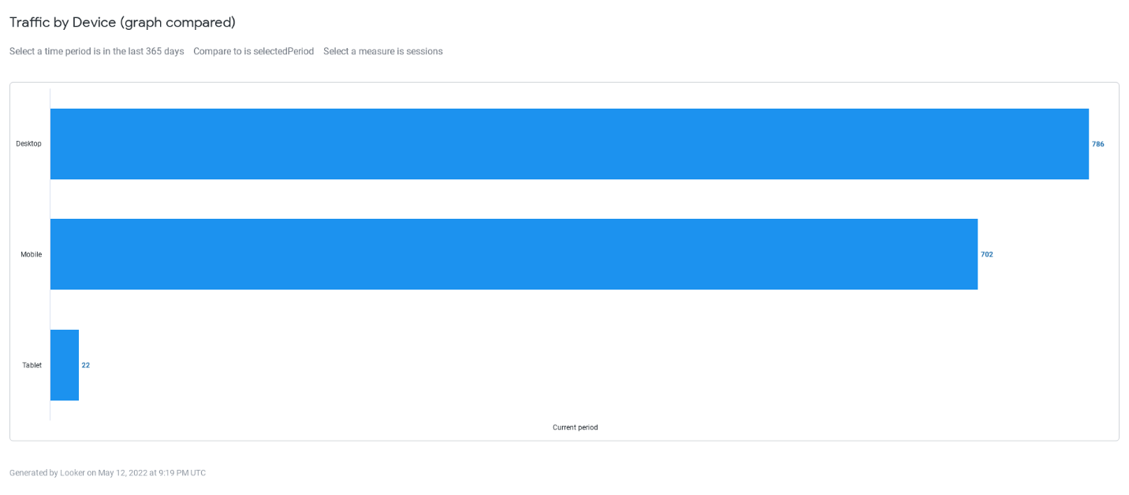
Device type | Page views | Site sessions | Unique visitors
Desktop | 2,507 | 786 | 494
Mobile | 1,590 | 702 | 403

Traffic by First Page Viewed
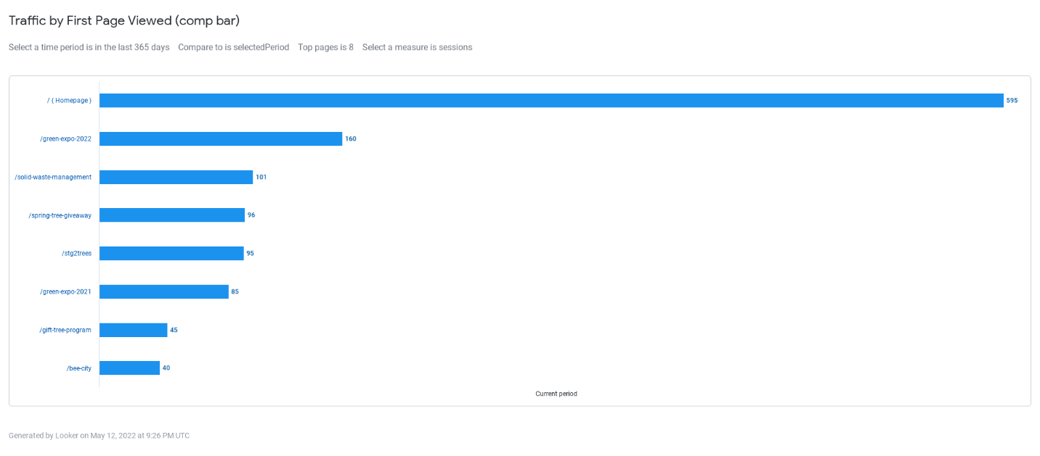
Entry page | Site sessions
Homepage | 595
/green-expo-2022 | 160
/solid-waste-management | 101
/spring-tree-giveaway | 96
/stg2trees | 95
/green-expo-2021 | 85
/gift-tree-program | 45
/bee-city | 40

Traffic by Referring Sites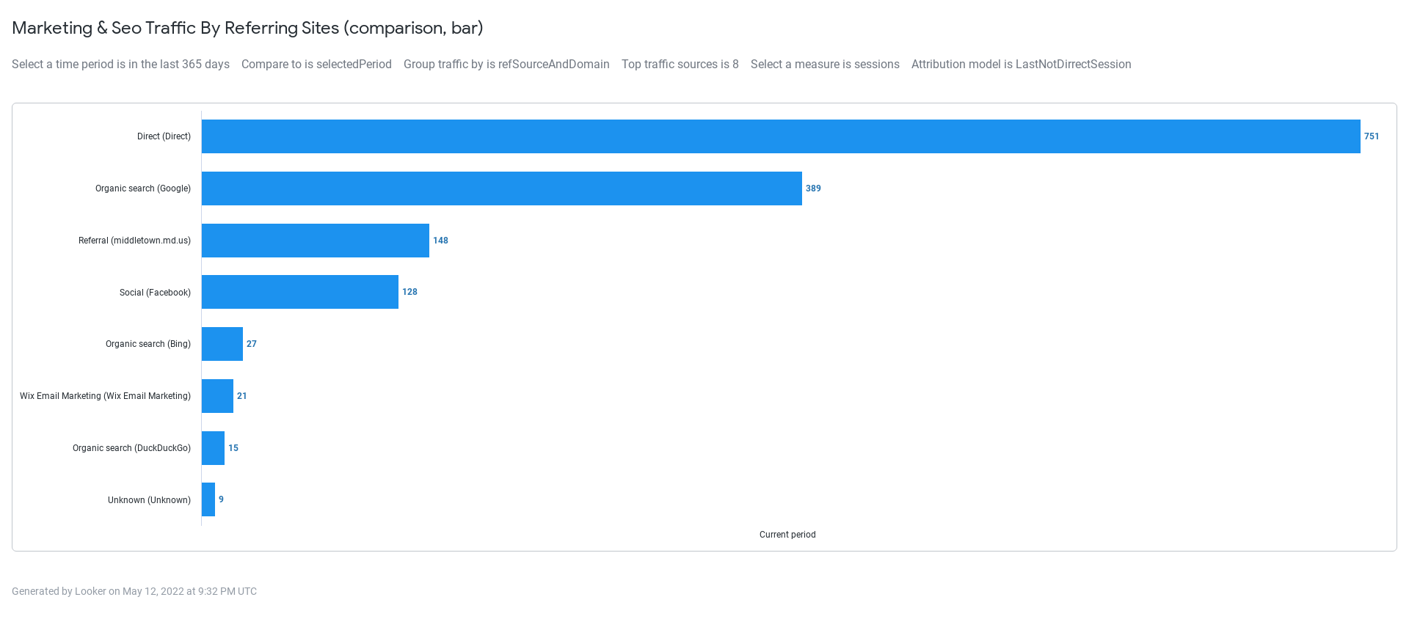
Traffic source and category | Site sessions
Direct (Direct) | 751
Organic search (Google) | 389
Referral (middletown.md.us) | 148
Social (Facebook) | 128
Organic search (Bing) | 27
Wix Email Marketing | 21
Organic search (DuckDuckGo) | 15
Unknown (Unknown) | 9

Traffic by Location
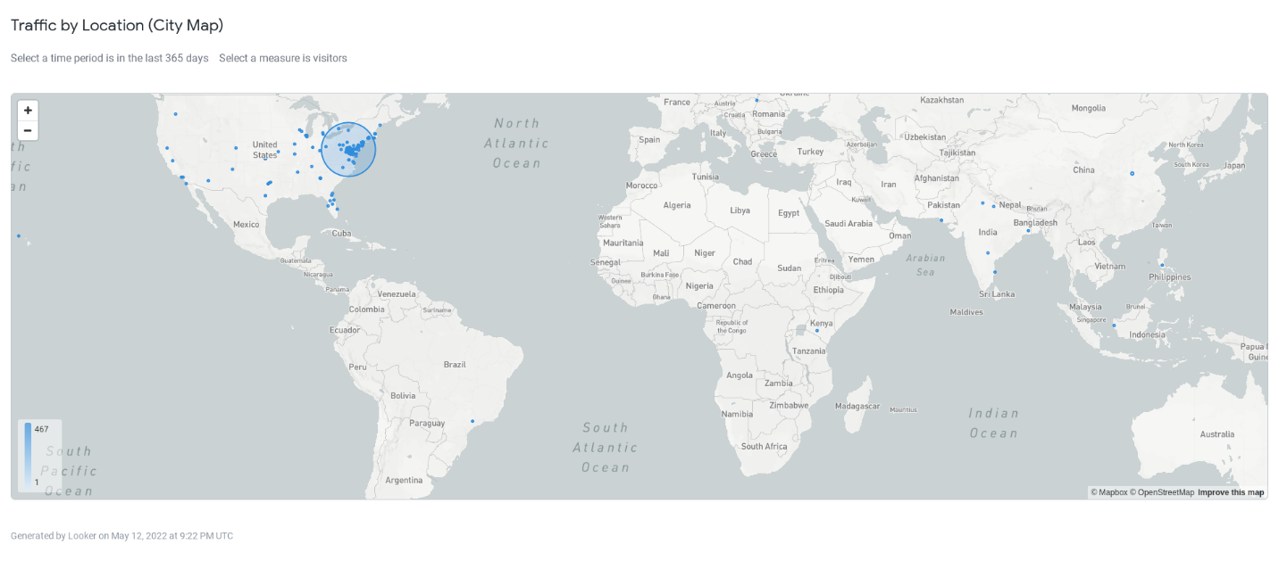
City | city_map | Unique visitors
Middletown | 39.4427,-77.5542 | 477
Frederick | 39.4442,-77.3393 | 89
Washington | 38.9522,-77.0253 | 79
Hagerstown | 39.6343,-77.7337 | 19
Baltimore | 39.303,-76.6062 | 18
New Market | 39.4114,-77.2823 | 17
Alexandria | 38.8155,-77.1205 | 11
Silver Spring | 39.0851,-77.059 | 10
Hyattsville | 38.9635,-76.9672 | 8
Falls Church | 38.8597,-77.198 | 13
Brunswick | 39.3086,-77.6278 | 6
Rockville | 39.0828,-77.1674 | 5
Annapolis | 38.9894,-76.5494 | 4
Gaithersburg | 39.109,-77.2489 | 4
Germantown | 39.1361,-77.2824 | 4
Laurel | 39.1063,-76.866 | 4
Catonsville | 39.2812,-76.7406 | 3
College Park | 38.9965,-76.934 | 3
Jefferson | 39.3642,-77.5404 | 3
Boonsboro | 39.5521,-77.7005 | 2
Mount Airy | 39.3886,-77.1683 | 2
Westminster | 39.5693,-76.9869 | 2
Myersville | 39.5248,-77.5531 | 1
Thurmont | 39.6128,-77.3991 | 1
Woodsboro | 39.5303,-77.2981 | 1

