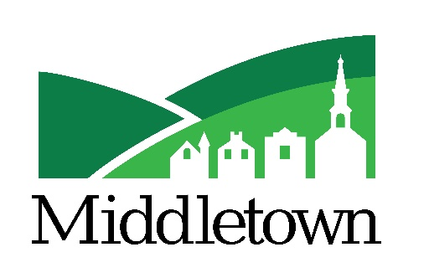

Downtown Revitalization Zone Incentive Program
Approved by Burgess & Commissioners
October 12, 2020

Purpose:

The Town of Middletown is furthering its efforts to revitalize the historic downtown by creating the Downtown Revitalization Zone (DRZ) Incentive Program with specific incentives to attract investment in Middletown’s timeless, older buildings. The Zone mirrors the Main Street district to further illustrate the Town’s commitment to keeping the historic downtown thriving as the core of our community. The Burgess & Commissioners have prioritized economic development and revitalization of these buildings to keep Middletown a vibrant, thriving town.
The potential benefits of this program include revitalization of vacant buildings, increased jobs, increased property tax revenues, preservation of building facades, and voluntary programs geared to historic preservation of our historical and architecturally significant buildings.

Qualifications:

- A pre-application meeting with Middletown staff, Middletown’s Main Street manager, and at least one elected official is required to discuss all aspects of the program.

- The revitalization project must be an existing building within the Downtown Revitalization Zone (see attached map).

- A minimum of $250,000 must be invested in the revitalization project (excluding purchase price).

- The façade of the building must be preserved, and a Concept Plan must be provided that demonstrates consistency of downtown character in size, scale, and materials.

- Execution of a Development Agreement to detail the obligations of both parties and specify the standards and conditions that will govern development of the property.
Incentives:

- Reduction in Water and Sewer Tap/Equivalent Dwelling Unit (EDU) Fees and Improvement Fees
The Town’s fees for water and sewer connection are comprised of three elements:
- Water Tap/EDU Fee
- Sewer Tap/EDU Fee
- Improvement Fee

Through Middletown’s Economic Development Grant Program, Water and Sewer Taps/EDU fees will be discounted by 50% for additional water and sewer capacity needed by the proposed redevelopment of the property, not to exceed the funded amount of the grant program.
The Improvement Fee is waived 100%.
Prevailing Rates DRZ Program Incentive Rates
Water Tap/EDU $9,000 reduced to $4,500
Sewer Tap/EDU $9,000 reduced to $4,500
Improvement Fee $7,000 reduced to $0
Total $25,000 $9,000
(Per Tap/EDU)

Capacity Calculations (number of Taps/EDU’s required) are based on either a Fixture Unit Count or Meter Size for the property. The required number of Taps/EDU’s will be calculated by Middletown staff.

- Deferred Payments of Water and Sewer Tap/EDU Fees – Payments may be deferred to coincide with cash flow and be defined and secured in the Development Agreement. Payments must be made quarterly, up to a maximum of 5 years or at point of sale. Payment term begins when a Certificate of Occupancy for the project is issued.

- Parking Requirements
Non-Residential parking requirements are waived 100%.
Residential parking requirements are waived 50% and additional parking waivers may be granted by the Planning Commission.

- Expedited navigation through Planning Commission/Board of Appeals – A Planning Commission Site Plan Checklist (attached) is provided and once all documents are received, reviews and approvals will be prioritized and expedited while meeting all Planning Commission and/or Board of Appeals procedures and legal requirements.

- Waive all Planning Commission/Board of Appeals Fees (over $3,000 savings)

- Kick-Off meeting with Middletown staff, Main Street manager, and at least one elected official.

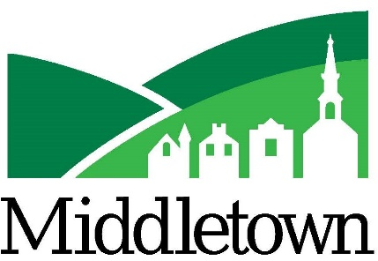

Downtown Revitalization Zone
Developer Application

Date: ____________
Address of Property: _______________________________________________________
Developer Name: __________________________________________________________
Address: _________________________________________________________________
Primary Contact Number: ___________________________________________________
Email Address: ____________________________________________________________
Zoning for Property: _______________________________________________________
Intended Use for Property: __________________________________________________
________________________________________________________________________
________________________________________________________________________
Water Service Demand: ____________________________________________________
________________________________________________________________________
Sewer Service Demand: ____________________________________________________
________________________________________________________________________

_________________________________________
Signature

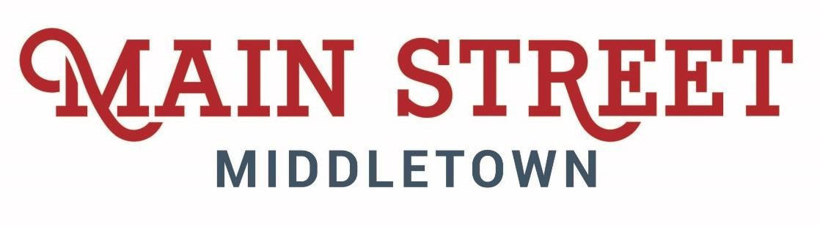
Thank you for choosing Middletown, Maryland, and welcome
to our community! Main Street Middletown, MD Inc. is the local nonprofit with a mission to support the downtown historic business district as the economically thriving center of our community. We do this through the nationally acclaimed National Main Street Program by implementing a historic preservation-based economic development strategy. Simply put, we love our historic buildings and character, as well as the businesses that own and occupy these unique spaces. We work to bring folks (read potential customers) downtown through advertising campaigns in print, digital, and TV and host several festivals. We support businesses through financial incentives, host monthly meetings, often with technical assistance, and we encourage business owners to work together and cross promote each other.

: The workhorse financial incentive that Main Street Middletown MD Inc. offers is our Façade Improvement Program.
How it Works: Each year, Main Street Middletown applies for state funds to fill our coffers based on upcoming work, so each year our fund amount is different, based on demand. Property owners complete an application (which can be downloaded at www.mainstreetmiddletown.org), the Main Street Design Committee reviews the package for completeness and forwards the application to the state. The State reviews the proposed project for potential impacts to the historic character of the property. Usually the review period is about 1-week long. Once Main Street gets the “Ok” from the State, we alert you so that you can move forward with those specific tasks.
When the work is complete, the property owner will provide another set of documentation, consisting of proof of payment for the described work, and photos of the finished project to Main Street
Middletown. We proof the submittal for completeness and then request the state for reimbursement.

Reimbursement varies from community to community. The way Main Street Middletown, MD Inc has set up our reimbursement rate is UP TO 50% of your costs up to our funding amount provided by the state. The maximum amount that can be refunded is $50,000.

 There are additional tax credits that can be used for many of
Middletown’s properties since many properties are considered historic and are contributing resources to Middletown’s National Register Historic District. If you need assistance in determining if the property you are interested in is considered a contributing historic property, please feel free to call the Main Street Manager, Becky Axilbund at 301-371-6171, Extension 111.

Town of Middletown Tax Credit – for improvements made to commercial structures within the Town, the new assessed value of the improved property will be taxed at 20% the first year, 40% the second year, 60% the third year,, 80% the fourth year, and the full amount in the fifth year after project completion. For more information about this incentive, please contact the Town Administrator, Drew Bowen at 301-371-6171.

Maryland Sustainable Communities Rehabilitation Tax Credit – this program provides a State income tax credit and is available for commercial, income producing properties, including office, retail, and rental housing. Visit the Maryland Historical Trust to view requirements and forms, or call staff at 410-514-7628.

Federal Historic Preservation Tax Credits – administered by the National Park Service, this program provides a federal income tax credit based on the qualified rehabilitation costs of a certified historic structure (many properties in Middletown are considered a certified historic structure). This program is coordinated through the Maryland Historical Trust and additional information can be obtained through calling 410-514-7620.
the Main Street Manager, the Main Street Board of Trustees, and our
regional and statewide partners are advocates for small business owners. We are here to help you! We encourage you to please contact us. We are always excited to discuss new projects and assist you in this endeavor.




Becky Axilbund,
Main Street Middletown Manager
19 West Main Street, Middletown, MD 21769
301-371-6171, Extension 111
www.MainStreetMiddletown.org

BAxilbund@ci.middletown.md.us

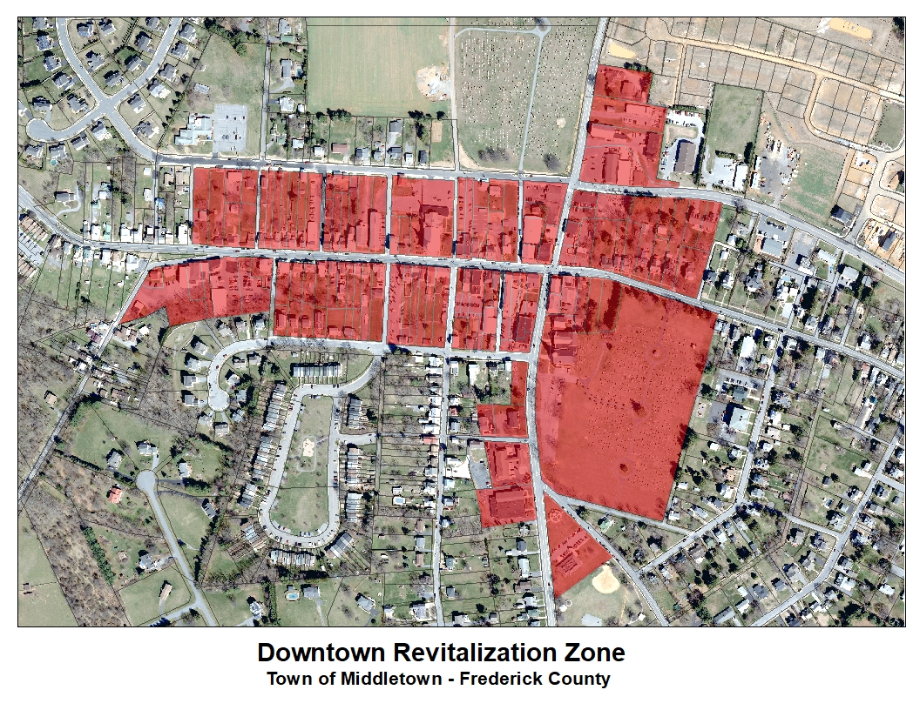
MIDDLETOWN
PLANNING COMMISSION SITE PLAN CHECKLIST

- Site Plan Requirements (Middletown Municipal Code Section 17.32.240)
  - Existing Conditions - shown on Site Plan
    - General plan of development for the property showing entire tract to be developed/redeveloped and drawn to scale; acreage; names of adjacent property owners; current zoning classification
    - Property address, name and addresses of owner, developer, and the designer/surveyor/engineer
    - Scale, north point, and date
    - Approval block for the planning commission
    - Topography – contours at five-foot intervals, if warranted
    - Physical features – buildings, utilities, other significant items, along with sizes and grades of any water or sewer lines
    - Locations, widths and names of existing roads, or other public ways within or adjoining site; utility or other rights-of-ways or easements
  - Proposed Development/Redevelopment – shown on Site Plan
    - Proposed/Existing Buildings – layout and dimensions of all buildings; for condominium or multi-family projects (apartment, townhouse, etc.) the total number of units in each building shall be shown (Municipal Code Section 17.32.240)
    - Open Spaces – portions of property intended for public use and arrangements for ownership and maintenance
    - Utilities – locations for utilities and drainage facilities, with easement for same
    - Building setback lines along all streets and property boundaries, with amount of setback indicated for each
    - Proposed use of property (retail, commercial, residential, mixed use)
    - Proposed method of stormwater management if necessary due to area of land disturbance.
    - Landscaping if necessary/planned (Municipal Code Section 17.20.050)
    - Outdoor lighting plans including photometric data and foot-candle readings (Municipal Code Section 17.32.245)

Architectural rendering including materials proposed and elevations and showing any exterior structural changes (Municipal Code Section 17.20.050)

Parking and loading (if needed) spaces proposed (Municipal Code Sections 17.32.060 & 17.32.070)

Dumpster locations and proposed screening (Municipal Code Section 17.32.045)

Middletown
Downtown Revitalization Zone Incentive Program
Concept Plan

A. The concept plan shall be submitted electronically and shall be clear and legible;
B. Vicinity map indicating the location of the property with respect to surrounding property and streets. Show all property owned according to tax map if only part of the property is being developed;
C. Title information:
1. Proposed name,
2. Scale of plan,
3. Date;
D. Name and address of the owner and person responsible for the preparation of the plan;
E. North Point;
F. The plan shall show topography at five-foot contour intervals if warranted;
G. Location, widths and names of all streets or alleys on or adjoining the property; and all existing easements (to be indicated with dashed lines);
J. Location of existing utilities on or within two hundred (200) feet of the property;
K. The approximate location and area of all property proposed to be reserved to public use;
L. Zoning district classification;
M. Proposed use of property (retail, commercial, residential, mixed use);
N. In cases of multi-family projects (apartment, townhouse, etc.) the following additional items shall be shown:
1. Approximate location of each building,
2. Total number of units in each building,
3. Number of parking spaces in each off-street parking area, and total thereof,
4. Interior road or street access, whether public or private.
O. Preservation of the façade of the building
P. Consistency of downtown character in size, scale and materials

