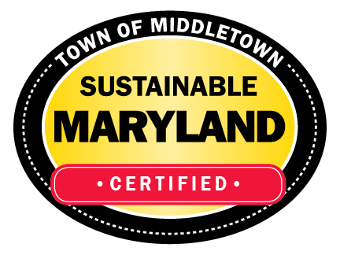
CONTACT INFORMATION:
Town of Middletown, Sustainability Committee—Green Team
Ann Payne, Cindy Unangst
paynestake@gmail.com; cunangst@ci.middletown.md.us

RELEASE DATE:
June 15, 2022

SUMMER IS HERE AND SO ARE THE MOSQUITOS
Learn Ways You Can Safely Control Mosquitos While Protecting
the Watershed at the Same Time

[Middletown, MD] Dr. Paul Leisnham, distinguished Associate Chair and Director of Undergraduate Studies for the Environmental Science and Technology Department at the University of Maryland at College Park will be speaking at Middletown Branch Library on June 25, 2022, from 11:30 a.m. to 12:30 p.m. on the topic of mosquito control.
Dr. Leisnham will discuss his research on watershed health and sustainability, ways non-scientists can identify troublesome mosquitos, and environmentally compatible solutions to control those few mosquitos that pose a threat to human health. In his work, he collaborates directly with communities to help find viable solutions to make summer outdoor fun safer by controlling biting mosquito populations.
Middletown Branch Library is located at 101 Prospect Street in Middletown, MD. On-site parking is available but limited. Additional parking can be found on the street nearby as well as in several municipal lots near the town center. Carpooling is suggested.
The talk is sponsored by the Middletown Sustainability Committee (Green Team)..whose mission is to conserve Middletown’s shared natural resources, including land, air, water, open spaces, and viewsheds. By working in partnership with our schools, nonprofits, faith-based organizations, businesses, and residents, we can sustain natural resources and promote healthy living for generations to come. We will accomplish our goals by creating understanding in our community, promoting involvement by way of education, and addressing environmental challenges and opportunities by focusing on economic, environmental, and social stability. For more information, please see the Green Team’s website: https://www.greenmiddletown.com/.

